**ACTIVITY 1**

Open Microsoft Word and type the letter below just as it is, then perform tasks listed below. Save on desktop as **Personal Letter and your name (E.g. Personal Letter-John Brown)**

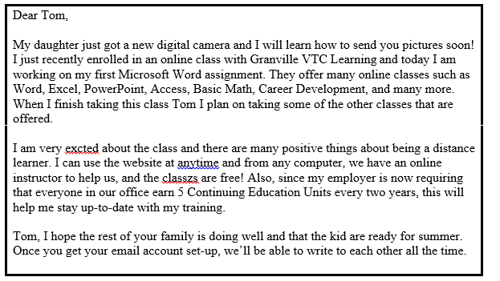

**TASKS**

1. Use the **Drag and Drop** feature to move the first sentence of the letter (“My daughter just got…”) to the **end** of the **final** paragraph of the letter. 2 Marks
2. Use the mouse to **select** the 3rd paragraph.
3. Use the **Copy**, **Paste**, and **Cut** features to move the 3rd paragraph so it is the second paragraph of the letter. Spell check the document to ensure there is no errors.

3 Marks

1. Use the **Find and Replace** feature to change the name of the person you are writing from "Tom" to any name you choose. 3 Marks
2. **Bold and underline** Word, Excel, PowerPoint, Access, Basic Math, Career Development in the first paragraph. 2 Marks
3. Save and close the document.

Send your file to [hallshaneil47@gmail.com](mailto:hallshaneil47@gmail.com) and upload to Moodle

3 Marks

**ACTIVITY 2**

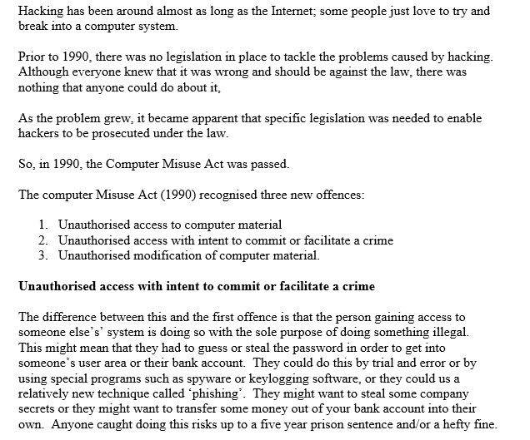

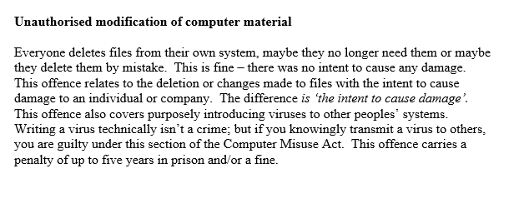

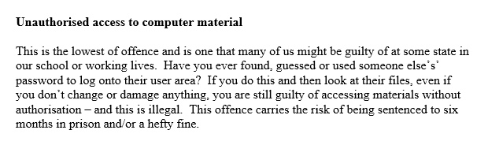

**INSTRUCTIONS**

1. Type the document given exactly as displayed on handout

8 Marks

1. Insert a header with your first and last names aligned right 3 Marks
2. The paragraph headings – should be formatted as follows: 12 Marks
3. They should be centred, underlined, bold
4. Font size: 14
5. Format the font within the entire document as follows:
6. The colour of the document should be changed to either red or blue
7. The Font Style should be changed to Courier New

2 Marks

1. Border the entire document 1 Mark
2. Change the line spacing of the entire document to 2 or double. 1 Mark
3. Indent the first line of all paragraphs to 0.5”. 4 Marks
4. Use an appropriate WordArt style to enter the Title: **Computer Misuse Act**

2 Marks

1. Download appropriate pictures and insert one under each Misuse Act.

6 Marks

1. Change the margin setting to the following:

Top: 0.5” Bottom: 0.5”

Left: 1” Right: 1”

2 Marks

1. Save the document as **Computer Misuse – Yourname** and send to [hallshaneil47@gmail.com](mailto:hallshaneil47@gmail.com) and upload to Moodle

3 Marks